Rainbow Preschool

2022-2023

Nokesville Church of the Brethren
P.O. Box 56
13002 Fitzwater Drive
Nokesville, VA 20182

703-594-2685

http://rainbowpreschool.us
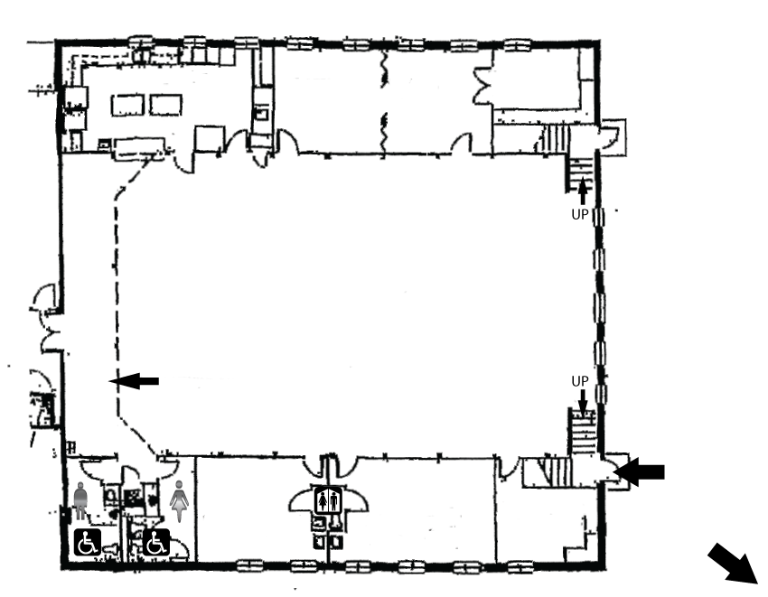
Description of Facilities
[15’ x 14’]

[15’ x 14’]

- The size of the building is described in the floor plan above.
- Four classrooms are used for the center.
- The kitchen facilities are available for use by the center.
3 Year Old
Room
[23’ x 14’]
4 Year Old
Room
[18’ x 14’]
Multi-Purpose Room
[74’ x 41’]
4 Year Old Room

[29’ x 14’]

Kitchen

Workroom

Workroom

(walkway above)

Preschool Entrance

To Playground

- Other signification features of the facilities include the multi-purpose room.
- Outside playground equipment consists of swings, slide, climbing
apparatus, and a sand box.

Check out our website at http://rainbowpreschool.us!
&
Like us on Facebook!

Rainbow Preschool opened in September 1986 and operates
in affiliation with the Nokesville Church of the Brethren.

Our goal is to provide a Christian atmosphere in which you
child feels safe and happy as he/she grows and discovers
his/her own abilities.

Program
The program at Rainbow Preschool focuses on the total development of your child. Learning, socialization, and fun are all included in our program.

Our curriculum is based on weekly themes. Our daily activities include free play, music, circle time, stories, projects, snack, and large muscle play (outdoors or indoors). A wide variety of art, craft, science, and math opportunities, are incorporated into our projects and activities. Our program also use the Learning Without Tears curriculum and Scholastic Magazines with all classes.

We promote the development of skills such as sharing, listening, and following directions, which will help prepare your child for kindergarten. Above all, we hope to make your child’s first school experience a happy, positive one.

Staff

Suzanne Evans is the director and teacher. She has a degree in Child and Family Development. She has been with Rainbow Preschool since 1986. She taught in other preschools for three years and has taught in church school programs.

Tina Ringer is a teacher. She studied business at Strayer University. She has been a teacher and director for community after-school programs. Tina has been with Rainbow Preschool since 2014.
Amie Dean is a teacher. She has a bachelor’s degree in Psychology and has been with Rainbow Preschool since 2018. She has taught at various schools and has experience teaching preschool, Kindergarten, and 2nd Grade.
Melissa Ross is a teaching assistant who has been with Rainbow Preschool since 2020.

Karina Chan is a teaching assistant who has been with Rainbow Preschool since 2021.

Our maximum staff to student ration is 1:10.

Eligibility
Rainbow Preschool is open to all children three and four years old, or who will be three by September 30, 2022

Location
The school is located in the Nokesville Church of the Brethren, 13002 Fitzwater Drive, Nokesville. This is near the intersection of Nokesville Road (Rt. 28) and Fitzwater Drive.

Hours
School hours are from 8:45 a.m. - 11:45 a.m. Monday through Friday. If enrollment is high enough, we will also have classes 12:30 p.m. through 3:30 p.m. Monday, Wednesday, and Friday afternoons. Your child may attend three days a week or two days a week. Four year olds also have the option of five days a week, Monday through Friday. School begins Thursday, August 25, 2022 and closes May 26, 2023. We follow the Prince William County School calendar for holidays and snow days. If the public schools have a late opening, we WILL have school on that day.

Rates
The registration fee is $80/student or $125/family. For your convenience, tuition is divided into nine monthly installments. Your monthly payments are:

2 days per week (Tue/Thurs a.m.) $155.00 per month
3 days per week (Mon/Wed/Fri a.m.) $200.00 per month
5 days per week (Mon-Fri a.m.) $310.00 per month
3 days per week (Mon/Wed/Fri p.m.)** $200.00 per month
**Enrollment numbers will determine whether a p.m. program is warranted.

The first tuition payment is due by August 1, 2022. All others are due on the first day your child attends school each month. The last payment is due April 2023.. Please give 30 days written notice to withdraw your child from Rainbow Preschool to avoid payment of the next month’s tuition. If you need a monthly statement sent to you, please let us know. To keep costs down, we do not send statements unless requested.

Late Fees
A late fee of $20.00 may be charged for any child not picked up on time at the end of the preschool day. An additional fee of $1.00 per minute will be charged after the first 15 minutes. This fee will be due at the time of pick up.

Birth Certificate
According to Virginia guidelines we are required to verify each child’s identity and age. A staff member must view a certified copy of your child’s birth certificate for verification. Information about obtaining a certified copy of a birth certificate may be obtained by calling the Division of Vital Records at (804) 662-6200 or online at virginiabirthcertificate.com .
Health
A preschool physical including immunization records is required for children entering Rainbow Preschool for the first time. It is due by the first day of school. We can provide the form for your doctor to complete or it may be downloaded at http://rainbowpreschool.us/doc/school_entrance_form_copy.pdf . If your child is ill, including the beginning stages of a cold with a fever and sneezing, please keep him/her home for a few days. We will all benefit from your cooperation in this area.

Contact Information
If you would like to discuss your child or the preschool program, please contact your child’s teacher or director .

Suzanne Evans
Rainbowpreschool538@gmail.com

If you need to contact us during school hours please call the church office at 703-594-2685.
Field Trips
We will be taking field trips during the year. Prior to each trip a permission slip and information about the trip will be sent home. We will require a signed permission slip for your child to participate. Except for walking field trips, parents will be responsible for transportation.

Discipline
At the beginning of the school year, we carefully explain to the children the school rules. In instances where discipline is necessary, we will redirect the child to another activity or away from the group in a supervised area. Physical punishment is never used.

Snack
We serve a snack each day. You are welcome to bring cupcakes or other special snacks for birthdays and holidays. Please contact your child’s teacher in advance.
We are a peanut/nut free program.

Party Invitations
Please do not send birthday party invitations to school to be passed out. Feelings are often hurt when an entire class is not invited and invitations sometimes are lost or get stuck in the back of “cubbies” until after the party. We will be happy to help you with addresses or phone numbers when you are planning a party. If at any time you do not want your address or phone number given out, please let your child’s teacher know. Thank you for your cooperation.
Clothing and Personal Belongings
Play clothes and shoes are most practical for preschool wear. Keep in mind that we will be going outside when the weather permits and dress your child accordingly. We provide smocks for painting.

Toilet Training
Your child should be toilet trained before entering preschool. If he/she is having some problems or needs some extra help, please let us know.

Transportation
We do not provide transportation but encourage you to form car pools. If we can be of help in letting you know who may live near you that might be interested in car pooling, please let us know.

Exemption
In compliance with the Code of Virginia, this center is exempt from licensure and is classified as an “Exempt” child day center.

Enrollment Capacity
The maximum number of children that the center will enroll in each program is 35 each day. This figure is dictated by the local building inspector.

Health Requirements for Staff
Staff employed at the center MUST be certified by a practicing physician to be free from any disability that would prevent them from caring for children. Documentation is on file at the center.

Child Abuse
Our staff is required by Virginia State Law to report any suspicions of child abuse.

The center is covered by public liability insurance, which provides coverage in the event that someone brings suit for personal or bodily harm suffered during the operation of the center as a result of negligence.
Registration
Registration opens February 1st for families returning to Rainbow Preschool. Open registration begins on February 15th.

By returning the enclosed form and registration fee, you will hold your child’s place for the upcoming year. A medical form including a record of immunization is due on or before the first day your child attends school. We also need to see your child’s original birth certificate before school begins. It will not be kept.

We may have an open house prior to the beginning of school. A letter will be sent by mid-August with more information. If you have any questions or would like to visit the school before that time, please call Suzanne Evans at (703) 594-2685.

We look forward to meeting your child.

Sincerely,

Suzanne Evans
Director

http://rainbowpreschool.us

Rainbowpreschool538@gmail.com
Rainbow Preschool

Nokesville Church of the Brethren
P.O. Box 56
Nokesville, VA 20182
703-594-2685

